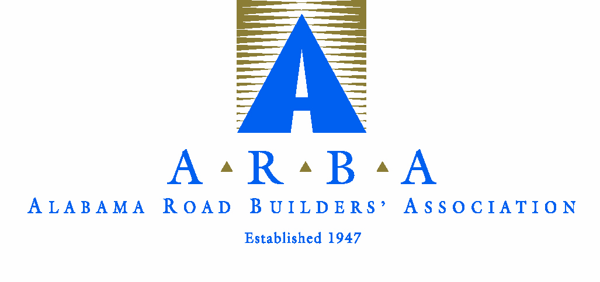
Alabama Road Builders Association
Annual Luncheon and Installation of Officers and Directors
Thursday, September 30, 2021
Montgomery Country Club
Reception 11:00 Lunch 12:00

SPONSOR REGISTRATION
Register now to be a sponsor for the Annual Luncheon. Your company name will be included in the printed program and on sponsor signs. Return the registration information below to Lexie or Terri by September 13th
to be included in printed materials.

PLATINUM SPONSORSHIP (includes 6 seats for the luncheon) $1000 ________

GOLD SPONSORSHIP (includes 4 seats for the luncheon) $750 ________

SILVER SPONSORSHIP (includes 2 seats for the luncheon) $500 ________

BRONZE SPONSORSHIP $___ ________

Additional seats will be $75 each. Number of add'l seats ____ @ $75 ea. ________

TOTAL ________

Company Name: ____________________________________________________

Contact Name: ____________________________________________________

All guests names AND their company name:

____________________________________________________________________

____________________________________________________________________

____________________________________________________________________

Return to: lexie@alrba.org or terri@alrba.org

Dress for this event is COAT & TIE

